

MSc in Computing - Team Project
User Evaluation Report
Group 2 – Housing Made Easy (H.M.E)

Table of Contents
1. Proposed Hypothesis 2
2. Experimental Method 4
2.1 Overview 4
Low Fidelity Prototype Testing 4
Iconography Survey 5
Medium Fidelity Prototype Testing 5
High Fidelity Prototype Testing 6
2.2 Data Collection 6
2.3 Selected Subjects 7
2.4 Data Analysis 7
2.5 Practical Setup 8
Low-Fidelity 8
3. Conclusions 9
4. References 9
5. Appendix 10
5.1 Demographic Survey 10
Post analysis data visualisation 10
5.2 Low Fidelity Prototype testing 12
Sequence Questions 12
Results summary 13
5.3 Iconography and Language Survey 15
Results 15
5.4 Medium-Fidelity Testing 16

1. Proposed Hypothesis

This project is a proof-of-concept and will focus on creating a rental listings application for Baltimore (Maryland, USA) which also incorporates the crime rate of an area. The app will focus on tenant experiences with future development encompassing landlord experiences. User profile information will also be used for a property recommendation system (based on the users’ personal requirements).

Initial demographics research has suggested that existing listings sites do not provide a satisfactory user experience. The goal of the project from the UX design perspective is to create an improved user experience over existing websites.

Prior to user evaluation, exploratory work was conducted in the form of a demographics survey and answered the key demographic questions:
- Who is our core user demographic?
- What devices do users use?
- What factors do users consider when searching for a home?
- What do users want in terms of features?
- Are users interested in a recommendation system?

According to the Central Statistics Office (CSO), most 20–30-year-olds rent with a large proportion being students.
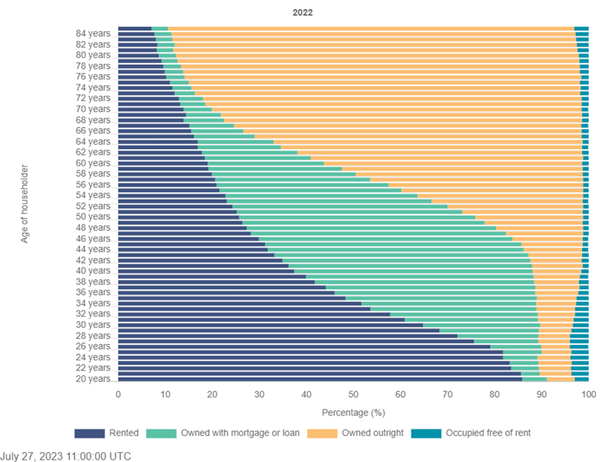
[Home ownership and rent - CSO - central statistics office. CSO. (2023, October 20)]
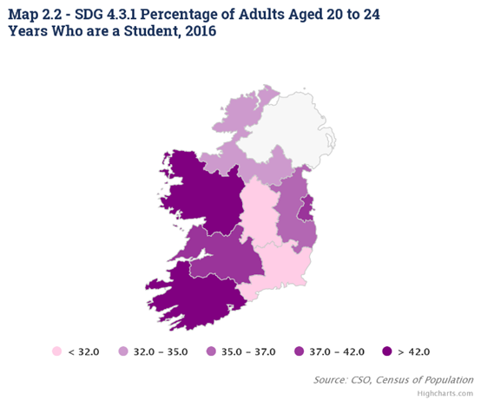
[Adult education - CSO - central statistics office. CSO. (2020, August 19)]

The output of the demographics research was a list of commonly experienced problems by people and two user personas, Jenni, and Andre, which represent the younger/older adult populations and typical user stories. These personas were developed under the ‘Tenant’ role, to reflect the chosen experience being developed by the project. This methodology is sourced from GroupVisual.io, wherein each persona has shared objectives, but differentiated through the context of their individual characteristics (GroupVisual.io, 2018).

Once the user base was identified, the team could start to identify the following core questions, which will be discussed in further detail throughout this report.

- Does the site meet the use cases required by the target users?
- Is the site usable and accessible?
- Is the site aesthetically pleasing?
- Is the site more usable and/or accessible than existing listings sites?

Most people in their 20’s would be more technically literate than a person in their 50+ years old, a fact confirmed by the central statistics office.

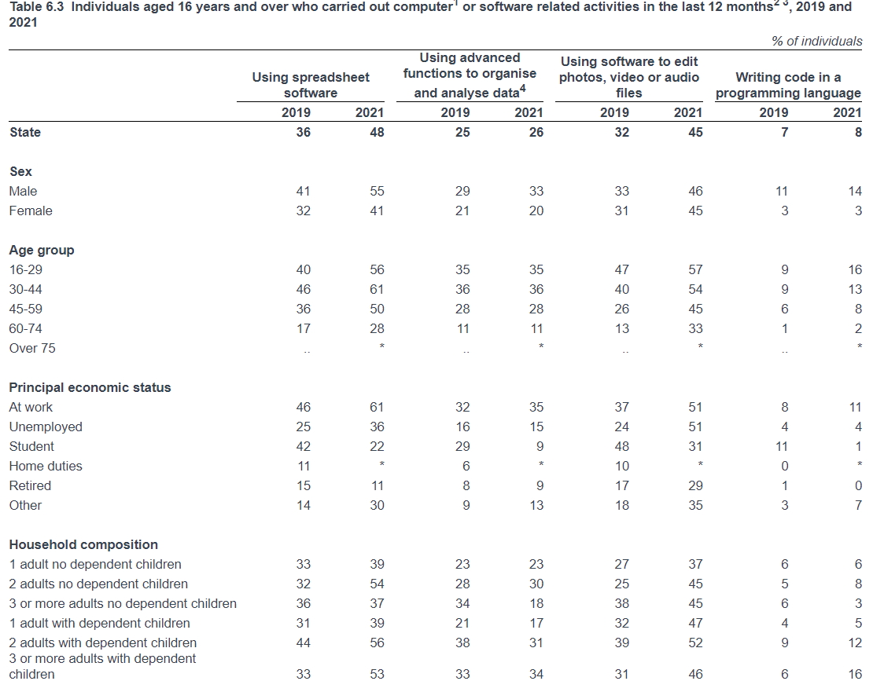
(ICT skills and online learning - CSO - central statistics office 2021)

2. Experimental Method

2.1 Overview
The overview of the experiments is summarised in the table below. However, experiment details will be discussed further in later sections. The demographic survey is not discussed, as it is considered user identification.

Low Fidelity Prototype Testing

Objective:
Identify major issues in site layout and receive feedback on early system implementation.

Conditions:
Online or in-person observation and interview.

Methodology:
Using Figma designs, users were interviewed about various tasks and the overall layout of the Figma layouts. An example case is demonstrated in subsequent sections.

Figma mock-ups of the site’s interface were embedded into a PowerPoint presentation, in sequences matching typical user processes. (e.g., Sequence of design mock-ups to reflect process of browsing listings). Each sequence was broken into multiple tasks.

For each task, participants were asked to identify and hover their mouse over the relevant screen element in the mock-up. Participants could not proceed to the next slide until the correct element was highlighted. After successfully identifying the correct screen element, participants were asked to rate the difficulty of the task on a scale of 1-5 (easy-difficult). This is an example of a SEQ, a post-task questionnaire methodology (World Leaders in Research-Based User Experience).

After each sequence, users were asked to give overall feedback: aesthetics, layout, problems, likes and dislikes.

Screen and audio recordings were created for each testing session to enable further analysis.

Baseline and Evaluation Metrics:

No baseline

Evaluation:
- Users rating task difficulty. [1-5] (Quantitative)
- Rough estimated time users take to complete tasks. [seconds]
- Overall user feedback. (Qualitative)

Iconography Survey

Objective:
To Identify whether the icons chosen to represent different features of the system (I.e., saving properties for later viewing) match user mental associations.

Conditions:
Unsupervised online survey.

Methodology:
- Online survey was distributed through various social channels.
- Broken up into the following sections:
- Demographics
- Language associations
- Iconography association
- Language and iconography associations
- Duplication of language and icon questions to guarantee ensure consistency in answers.

Baseline and Evaluation Metrics:

No baseline

Evaluation:
- Sentiment analysis: quantifying overall sentiment towards language and iconography.
- Overall user feedback.

Medium Fidelity Prototype Testing

Objective:
To gather preliminary comparative usability and aesthetic ratings for H.M.E.

Conditions:
In-person observation and interview.

Methodology:
The user is asked to complete a series of tasks on Zillow and H.M.E using screen shots. and rank the difficulty of these tasks on a scale of 1 – 5 (easy – difficult) the time taken to complete each task is measured. In addition, the user is required to explain their reasoning to the interviewer.

In-person observation allows for more accurate task time data collection because there is no network lag.

Baseline and Evaluation Metrics:

Baseline:
Comparative with Zillow, measure the time taken to complete these tasks.

Evaluation:
- Users rating task difficulty.
- Time users take to complete tasks.
- Overall user feedback.

High Fidelity Prototype Testing
*Note: This is still within the design phase and is subject to change.

Objective:
To determine future work and finalise comparative usability and aesthetic ratings for H.M.E.

Conditions:
In-person observation and interview.

Methodology:
To be carried out during week 11 (December 1st, 2023)

The user is asked to complete a series of tasks on H.M.E. and Zillow and rank the difficulty of these tasks on a scale of 1 – 5 (easy – difficult) the time taken to complete each task is measured. In addition, the user is also required to explain their reasoning to the interviewer.

Baseline and Evaluation Metrics:

Baseline:
Comparative with Zillow, measure the time taken to complete these tasks.

Evaluation:
- Users rating task difficulty.
- Time users take to complete tasks.
- Overall user feedback.

2.2 Data Collection
For the language and iconography survey, the team wanted to:
- Identify users’ preferred language (e.g., the process for storing a search, users preferred “Save a Search”).
- Identify the language users associate with varying icons (e.g., Star icon was most associated with Favourite).
The survey had a mix of qualitative and quantitative data which was used as direct feedback for the team. User preferences are important as they make the website as intuitive as possible.

Much like the iconography and language survey, the prototype testing procedures also collect a mix of qualitative and quantitative data. Each prototype testing session collects the following data:
- Difficulty rating for individual tasks (Single Ease Questionnaire)
- Time taken to complete each task.
- Overall Feedback
  - Aesthetics.
  - Layouts.
  - Problems and/or difficulties.
  - Likes and/or dislikes.

By analysing the time users take to complete a given task against users’ difficulty ranking, the interviewer can verify the user ranking as well as identify problem areas, (e.g., Active tags in low-fidelity design being unclear). The users also gave specific feedback and possible solutions, “make the active tags larger and more distinct” and “have ‘main menu’ beside the menu button”.

Both the low and medium-fidelity test are working toward improving website usability, accessibility, and aesthetics; however, the comparative element of the medium-fidelity test also works toward answering “is the site more usable and/or accessible than existing listings sites?”.

2.3 Selected Subjects
The subjects for each phase of testing depends on whether the test is a survey or an interview. For the surveys, there is little control over who completes them as they are completed online. The demographic survey had mostly under 30’s completing it whereas the language and iconography survey had mostly 55+. The large age outliers for both surveys demonstrate that this is not a representative sample. Ideally it would be an equal number and gender from each age group. A Senior Research Officer from the National Statistics Office in the UK stated that ideally, there should be 30 people of each category for the surveys to be considered a true representative sample.

For the Low fidelity testing interview, the user sample were volunteers (friends and colleagues) with a more representative split. Half of the interviewees were in their 20’s, and half in the 50+ range. The gender split was a bit more uneven however with ¾ males to females.

For medium and high-fidelity testing, which will be interviews, volunteers will be used with a varying age and gender range. 10 subjects will be gathered for medium and high-fidelity prototype testing.

2.4 Data Analysis
Once the raw results were obtained from the demographics survey, the raw data exported to an excel spreadsheet, cleaned, and uploaded into tableau for data visualisation, this applies to the quantitative data only. For the qualitative data each of the comments and suggestions were sifted through and general sentiments were gathered. This enabled the team to identify the key user demographics and features, as well as note recommendation and concerns.

The insights from the demographic survey influenced the low fidelity website design. After the initial design was completed, user feedback was gained from an interview. Users were asked to rank the difficulty of each task and the time taken for each task was measured. The average difficulty was calculated for each task, as were the minimum and maximum ratings. This helped to identify areas within the low-fidelity design that would need refactoring. User feedback was also invaluable to low-fidelity design refactoring. An example of such feedback was multiple users stating that the iconography used in the low-fidelity design was unclear, and an expert reviewer recommended A/B testing for icons.

The A/B icons testing was combined with a language association into a survey. The survey was deployed using MS Forms which automatically visualises the quantifiable data. It also generates a word cloud for qualitative data, however individual answers were still analysed for any potential feedback that could be applied to the medium-fidelity website. The results from this survey were contradictory, this will be discussed later.

The feedback from the iconography survey was applied to the medium fidelity testing which is currently underway. This will be an interview style test and will follow the same data analysis methodology as the low-fidelity interviews, however it will also include a comparative analysis between Zillow and H.M.E. The feedback from this test will contribute to the refactoring of the high-fidelity website design.

2.5 Practical Setup
Both surveys conducted were online, there was no control over how or when or who did the surveys.

Low-Fidelity
This testing was conducted online. The users were sent the PowerPoint presentation when the test was started. The following instructions and questions given:

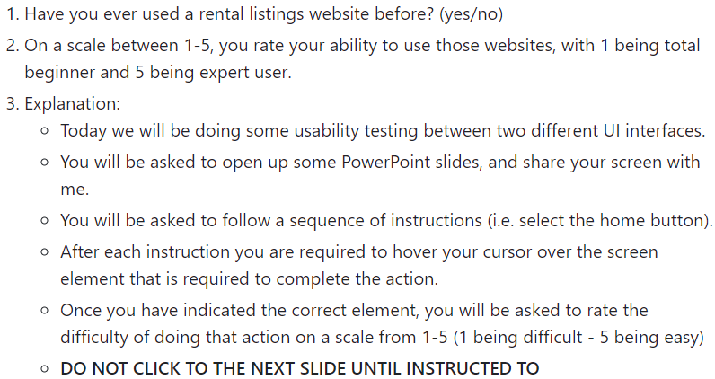

After the pre-questions and instructions were given a series of questions were asked. The questions were separated into the following tasks (the sequence for each task can be found in the appendix):

- Browsing Page (list view)
- Favouriting Sequence
- Applying Sequence
- Save Search Sequence

The participants were in a quiet room without background distractions. The questions for each of the tasks were not viewable by the participant, however it was visible on the interviewer’s screen. Each of the interviews were recorded for later viewing. For each question in the task the following questions were asked (apart from question 5 which will be used for medium-fidelity testing);

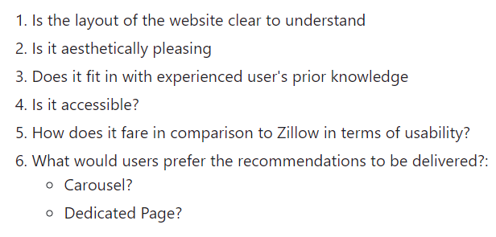

Medium-fidelity testing will follow a similar process to the low-fidelity testing; however, the interviews will take place in person within a booked room in the library. This ensures a quiet room with minimal distractions. The testing will be recorded for later analysis. The medium-fidelity test will have a series of pre-questions and instructions similar to those of the low-fidelity testing after which a script will be read. As this test is in-person, the questions will be printed out for the interviewer, the interviewee will not be able to view them. It is important to note, that the flow of the script for medium fidelity testing has been refined based on the feedback of other teammates, as well as a single external user.

As mentioned, High-fidelity testing will not begin until 1st December 2023. It will follow similar procedures to low and medium fidelity testing however users will be accessing the live website. The interviews will be conducted in person within a rented room in the library. The questions asked are not finalised. It is also undecided if this is to be a comparative test with Zillow/ Daft. The questions will be printed out for the interviewer, the interviewee will not be able to see them. All testing will be recorded for further analysis.

3. Conclusions
Conclusions cannot be drawn from the medium-fidelity testing as it is currently under way, this is also true of the high-fidelity testing which is scheduled to start in December 2023. However, based on the user testing that has been completed so far, the team can gain some insight. Users know what features they want available on H.M.E and were open to a recommendation system. Users considered crime rate when researching areas to move. These insights not only validate the need for a property listing website but also a property listing website that takes crime data into account.

The low-fidelity testing identified problem areas in the initial design, that the team did not recognise as well as indicated a need for icons testing. The analysis from the icons testing proved challenging and confusing, many users stated that the survey questions themselves were confusing which may explain the irregularity in terms of iconography and language (see table below).

Icon | Association | Accessing | Access Association
 | Store a Search | View Bookmarked Searches
 | Store a Property | View Favourite Properties
 | Store “apply documents” | View My Applications | 

In short, the key learnings from user testing so far are:
- Users identify problem areas better than the developers as the users have an external view.
- When the questions confuse the users, the user answers will be confusing.
- Not all users have technical experiences thus compromises will need to be made, expert reviewer inputs are invaluable for suggestions.

4. References

Adult education - CSO - central statistics office. CSO. (2020, August 19). https://www.cso.ie/en/releasesandpublications/ep/p-sdg4/irelandsunsdgs2019-reportonindicatorsforgoal4qualityeducation/adulteducation/#:~:text=The%20proportion%20of%2015%20year,of%20the%20population%20were%20students
GroupVisual.io. (2018, June 19). Personas vs. roles (how we research our users). Medium. https://medium.com/@groupvisualio/user-roles-vs-personas-246cc0a0a93d
Home ownership and rent - CSO - central statistics office. CSO. (2023, October 20). https://www.cso.ie/en/releasesandpublications/ep/p-cpp2/censusofpopulation2022profile2-housinginireland/homeownershipandrent/
ICT skills and online learning - CSO - central statistics office. CSO. (2021, December 10). https://www.cso.ie/en/releasesandpublications/ep/p-isshdcb/householddigitalconsumerbehaviour2021/ictskillsandonlinelearning/
World Leaders in Research-Based User Experience. (n.d.). Beyond the NPS: Measuring perceived usability with the SUS, NASA-TLX, and the single ease question after tasks and usability tests. Nielsen Norman Group. https://www.nngroup.com/articles/measuring-perceived-usability/

5. Appendix

5.1 Demographic Survey

Post analysis data visualisation
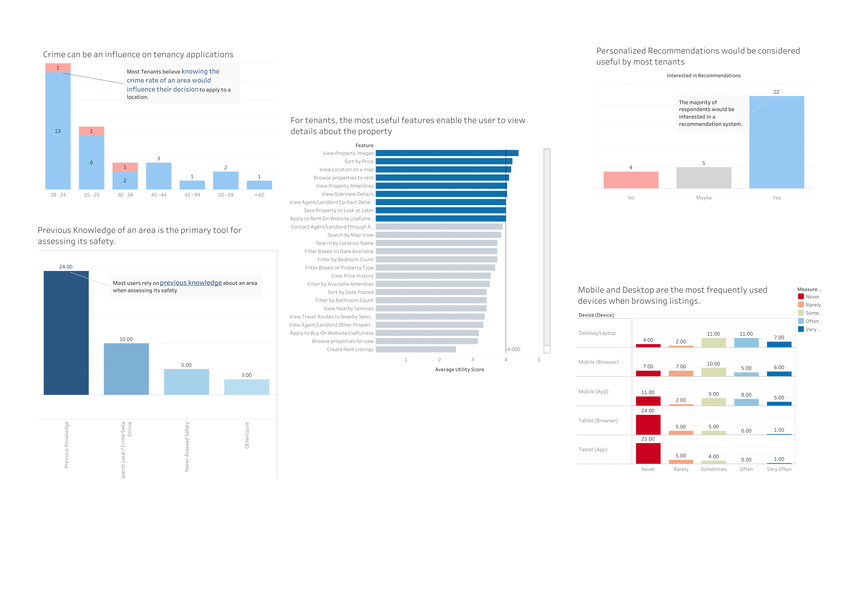








5.2 Low Fidelity Prototype testing

Sequence Questions
*Note: After each question, users were asked “On a scale of 1 – 5, rate how difficult it was to complete the task.” At the end of each sequence users were prompted for general comments.

Browsing + Filtering  Sequence | Favouriting Sequence | Make Application  Sequence | Saving Search Sequence
Please enter a location to search: | Please select a property to view: | Select a property to view: | Search a location using the search bar:
Please open up the search filters: | Save the property for later viewing: | Select apply: | Edit the filters:
Please select a filter: | Open the main site menu: | Select 'Complete Later': | Select some filters:
Please show on screen the current active filters: | Select Browsing: | Open the site menu: | Save the search:
 | Open the site menu: | Select my applications: | Open the main navigation:
 | Select my favourites: | Edit an application: | Select my searches:
 | Select another property: |  | Select the search again:

Results summary

Browsing and searching

Favouriting a property

Make an application

Save a search

5.3 Iconography and Language Survey

Results

Demographics

Language only
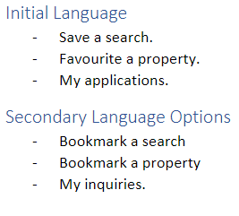

Iconography only
Image | Top 2 associations
 | - 20 % - List  - 16 % - Clipboard
 | - 36 % - Document  - 35 % - Page
- 54 % - Menu
- 33 % - Options/ list
- 73 % - Favourite
- 36 % - Bookmark
- 47 % - Like
- 36 % - Favourite
- 40 % - Bookmark
- 8.0 % - Save
 | - 21 % - No idea  - 6.0 % - Most favourite
 | - 51 % - Like  - 18 % - Approve

Language and Iconography
Icon | Association | Accessing | Access Association
 | Store a Search | View Bookmarked Searches
 | Store a Property | View Favourite Properties
 | Store “apply documents” | View My Applications | 

5.4 Medium-Fidelity Testing

